Exercise 2: E-commerce Platform Search Function
Scenario:
You are working on the search functionality of an e-commerce platform. The search needs to be optimized for fast performance.

Program:
Product.java
package dsa.ecommerce;
import java.util.Arrays;
import java.util.Comparator;

public class Product {
private int productId;
private String productName;
private String category;

public Product(int productId, String productName, String category) {
this.productId = productId;
this.productName = productName;
this.category = category;
}

public int getProductId() {
return productId;
}

public String getProductName() {
return productName;
}
public String toString() {
return "Product [ID=" + productId + ", Name=" + productName + ", Category=" + category + "]";
}
}

Ecommerce.java
package dsa.ecommerce;

public class EcommerceSearch {
public static Product linearSearch(Product[] inventory, int targetId) {
for(int i=0;i<inventory.length;i++) {
if(inventory[i].getProductId() == targetId) {
return inventory[i];
}
}
return null;
}

public static Product binarySearch(Product[] inventory,int targetId) {
int left = 0;
int right = inventory.length-1;
while(left<=right) {
int mid = left + (right-left)/2;
int midId = inventory[mid].getProductId();

if(midId == targetId) {
return inventory[mid];
}
if(midId > targetId) {
right = mid-1;
}
else {
left = mid + 1;
}
}
return null;
}

public static void main(String[] args) {
Product[] inventory = {
new Product(105, "Wireless Mouse", "Electronics"),
new Product(201, "Mechanical Keyboard", "Electronics"),
new Product(408, "Coffee Maker", "Appliances"),
new Product(599, "Gaming Monitor", "Electronics")
};

int targetId = 408;

System.out.println("=== Linear Search ===");
Product linearResult = linearSearch(inventory, targetId);
System.out.println("The Product found at "+linearResult);

System.out.println("\n=== Binary Search ===");
Product binaryResult = binarySearch(inventory, targetId);
System.out.println("The Product found at "+linearResult);
}
}
Output:
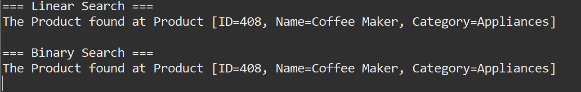

Analysis:
Binary Search is the overwhelmingly better choice for an e-commerce platform(sorted).
E-commerce platforms typically have massive databases containing thousands or millions of products. If a platform has 1,000,000 products:
- A Linear Search might have to perform 1,000,000 checks in the worst-case scenario.
- A Binary Search cuts the dataset in half every iteration. To search through 1,000,000 sorted products, it would take a maximum of just 20 checks in the worst-case scenario.

